Introduction:

The introduction of the Apple iPhone in 2007 marked a pivotal moment in the history of technology and communication. This revolutionary device not only transformed the way we communicate but also had profound and far-reaching impacts on various aspects of our lives, from business and education to social interactions and personal productivity. "iRevolution: A Data-Driven Exploration of Apple's iPhone Impact" aims to delve deep into the iPhone's influence by leveraging comprehensive data analysis and exploration.

In this data-driven exploration, we will uncover the multifaceted dimensions of the iPhone's impact on society, economy, and culture. The iPhone's journey from a cutting-edge communication tool to an integral part of our daily existence is a testament to its significance.

Over the years, the iPhone has not only evolved technologically but has also become a cultural icon, reshaping consumer behavior, industries, and even political landscapes. Through meticulous data collection and analysis, this study will provide a comprehensive overview of how this device has disrupted and transformed the world.

Purpose:

The purpose of an analysis titled "iRevolution: A Data-Driven Exploration of Apple's iPhone Impact" would likely be to comprehensively examine and understand the multifaceted impact of Apple's iPhone on various aspects of society, technology, and the economy. This type of analysis could serve several purposes are:

1. Economic Impact: Evaluate the economic implications of the iPhone, including its contribution to Apple's revenue and profit, job creation in the tech sector, and its effect on related industries such as telecommunications, app development, and accessory manufacturing.

2. Technological Advancements: Explore how the iPhone has driven technological advancements, both in terms of hardware (e.g., processors, camera technology) and software (iOS and the App Store), and how these innovations have influenced the broader tech ecosystem.

3. Cultural and Societal Impact: Investigate the iPhone's influence on daily life, culture, and social behavior. This may include examining changes in communication patterns, media consumption, and the rise of smartphone addiction.

4. Market Dynamics: Analyze the competitive landscape within the smartphone industry, including how the iPhone has shaped the market, affected rival companies, and influenced consumer preferences.

5. Environmental Impact: Assess the environmental impact of iPhone production, usage, and disposal, considering factors such as resource extraction, energy consumption, electronic waste, and Apple's sustainability initiatives.

Problem defining and Design thinking:

Empathy map:

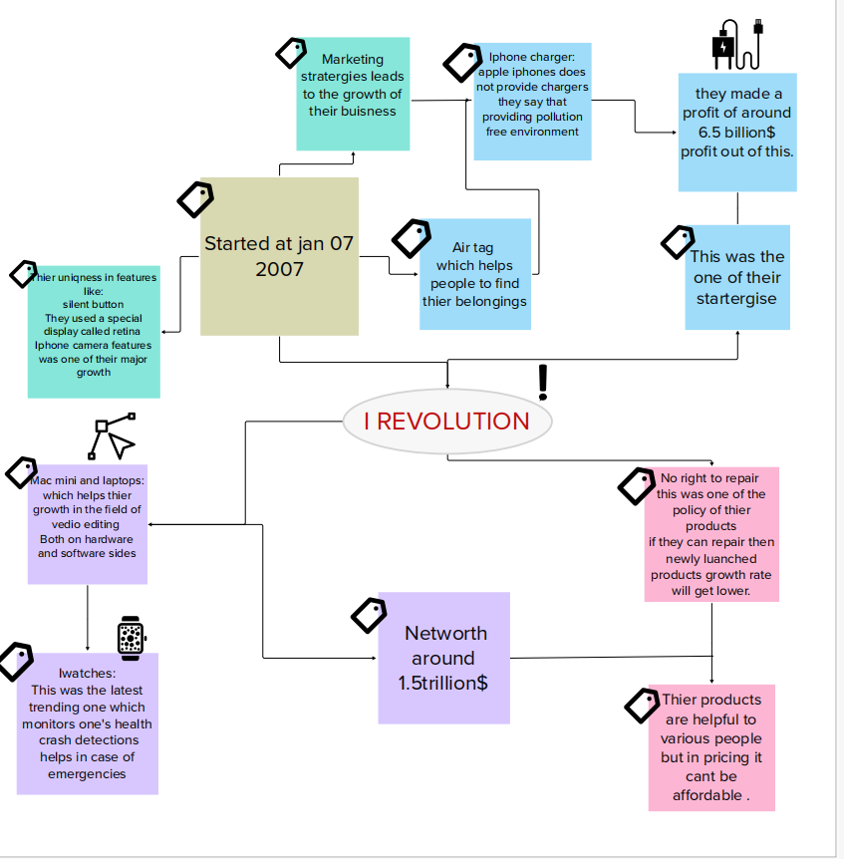

Ideation and Brainstorming:

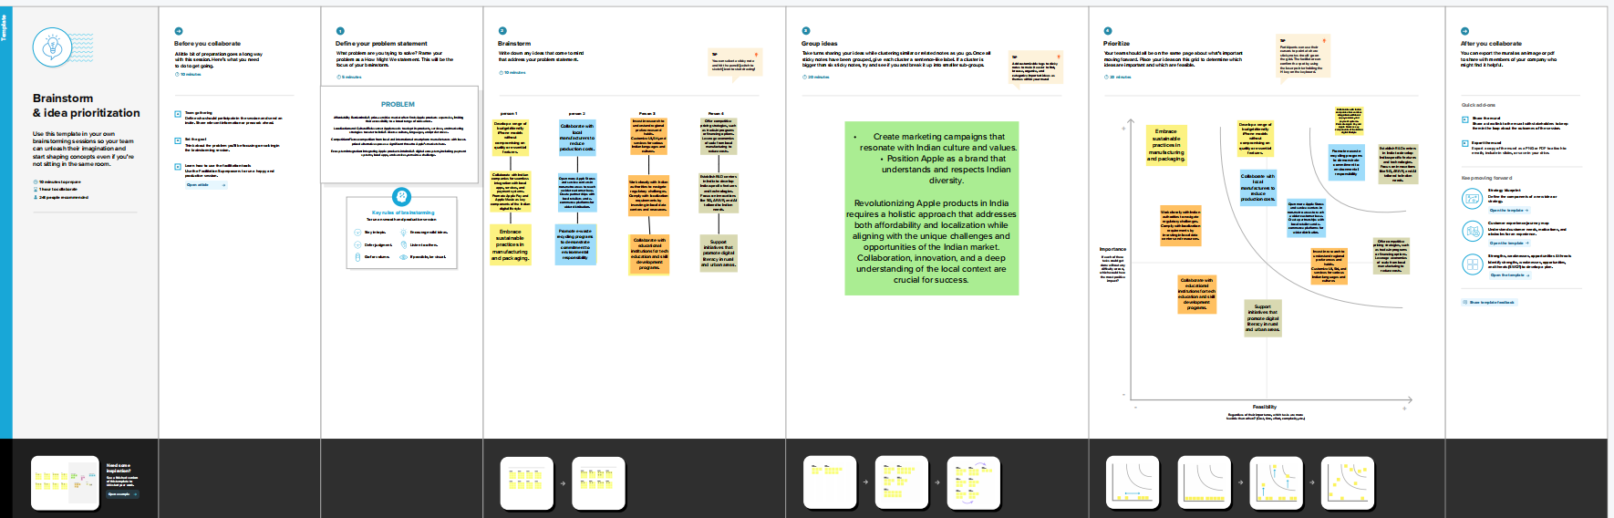

Result:

To conduct a comprehensive analysis of the iPhone's impact, you would need to consider these and many other factors, and you would need access to a wide range of data, research, and expert opinions. Additionally, the impact of the iPhone continues to evolve over time as new models are released and as technology and society change.

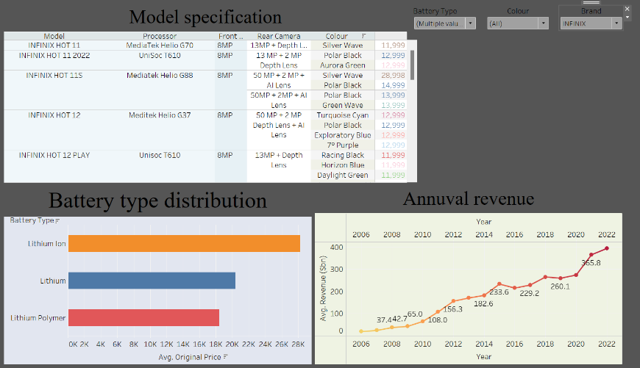

Advantages:

1. Economic Growth and Job Creation:

Data shows that the iPhone ecosystem has had a significant positive impact on global economies. It has created millions of jobs in various sectors, from manufacturing to app development. By stimulating the growth of the app economy, it has also contributed to the success of countless startups and small businesses.

2. Technological Innovation:

The iPhone's continuous evolution and the vast amount of data it generates have fueled technological innovation. It has pushed the boundaries of mobile hardware and software development, leading to advancements in areas such as augmented reality, machine learning, and 5G technology. This innovation not only benefits Apple but also the broader tech industry and consumers.

3. Increased Connectivity:

The iPhone's impact on data-driven connectivity cannot be overstated. It has facilitated global communication, making it easier for people to connect and share information. Social media, messaging apps, and video conferencing tools have become integral parts of our lives, driven by the iPhone's capabilities.

4. Health and Fitness Tracking:

Apple's focus on health and fitness features in the iPhone has had a positive impact on public health. Data collected through devices like the Apple Watch and iPhone apps have helped individuals monitor their health, track fitness goals, and even identify potential health issues early. This data-driven approach to health has the potential to improve overall well-being and reduce healthcare costs.

Disadvantages:

1. Data Privacy Concerns:

To perform a data-driven analysis of the iPhone's impact, you may need access to a vast amount of user data. This raises significant privacy concerns, as collecting and analyzing personal information without explicit consent can lead to ethical and legal issues.

2. Selection Bias:

Data-driven analyses are only as good as the data they rely on. If the data used is not representative of the entire population or if it contains biases, the analysis can produce skewed results. For example, if you rely on data primarily from urban areas, you may overlook the impact of the iPhone on rural communities.

3. Correlation vs. Causation:

Data-driven analyses often reveal correlations between variables, but establishing causation is much more challenging. While you may find that iPhone adoption correlates with increased smartphone usage, it's challenging to definitively prove that the iPhone caused this change.

4. Incomplete Data:

Gathering comprehensive data on the iPhone's impact can be challenging. Many factors, such as cultural and societal shifts, are difficult to quantify accurately. This can result in an incomplete understanding of the iPhone's full impact on various aspects of life.

5. Time Lag:

Data-driven analyses are often retrospective and based on historical data. This means that they may not capture the most recent developments and trends. In the rapidly evolving tech industry, the iPhone's impact continues to change, and a data-driven analysis may not provide insights into its current and future effects.

Applications:

1.Technoligical advancement.

2.Economic impacts.

3.social impacts.

4.Healthcare and education.

5.Environmental impact.

Conclusion:

In conclusion, the Apple iPhone has had a profound and lasting impact on society, the economy, and technology. It has redefined how we live, work, and communicate. While its benefits are substantial, the ethical and environmental implications of our tech-driven world call for ongoing reflection and responsible innovation. The iPhone is a symbol of progress and potential, but it also serves as a reminder of the responsibilities that come with technological advancement.

Future Scopes:

1. 5G and Connectivity:

With the advent of 5G technology, the iPhone will likely continue to evolve to leverage faster internet speeds, enabling new applications and services.

1. Augmented Reality (AR) and Virtual Reality (VR):

Apple has shown interest in AR and VR technologies, which could lead to the development of AR glasses or VR headsets, expanding the iPhone ecosystem further.

1. Services and Ecosystem:

Apple's services, such as Apple TV+, Apple Arcade, and Apple Fitness+, are growing. The company may focus more on bundling these services with iPhones to create a broader ecosystem.

1. Environmental Initiatives:

Apple's commitment to sustainability will likely influence its product designs, including the iPhone. This could result in more eco-friendly materials, repairability, and recycling programs.

1. Regulatory Challenges:

Apple faces regulatory scrutiny in various regions. Future regulatory changes may impact its business practices and market position.

Links :

Dashboard Link: <https://public.tableau.com/app/profile/prasanth.d1008/viz/Iphonerevolution/Dashboard1?publish=yes>

Story Public Link: <https://public.tableau.com/app/profile/prasanth.d1008/viz/Iphonereolutionstory/Story1?publish=yes>

Video demonstration Link: <https://drive.google.com/file/d/1TgXxoh_jI6Fly4l95szgUmKRgavUZO04/view?usp=drive_link>